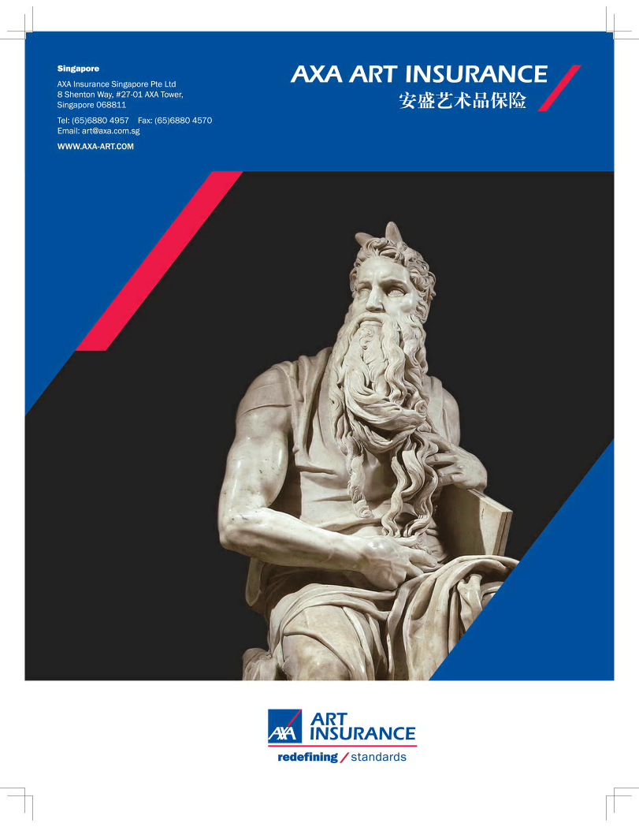
一般资料 GENERAL INFORMATION
受保公司名称
Name of Insured :
法人姓名
Name of Director
电邮地址
Email Address :
通讯地址
Mailing Address :
联络人姓名 / 资料
Contact Person / Details :
保险代理人及联络
Insurance Agent / Contact

各投保地址及投保额 LIMIT OF INSURANCE REQUESTED AT EACH LOCATION
各投保地址  List all locations where property is located |  |  |  | 投保额  Total Insured Value
1.
2.

投保物品中有否置于室外。如有，请明列地址和投保金额。
Do you request coverage for any item displayed outdoors? If yes, please advise of the location and sum insured value.

画廊运作operation
运作年数
Number of Years in Operation
此机构有无任何认证？ （请说明）
Are you or your institution accredited?
(Please specify)
如少于5年，其之前相关经验
If less than 5 years, then list previous experience

各项投保总额及地址 Percentage of Sum Insured by respective category of art stocks

经营范畴 Category | 按价值百分比  Value percentage |  | 按数量百分比  Quantity percentage
1. 书画,古藉,印刷Paintings, Drawings or Prints
2. 古玩,陶瓷,玻璃制品Ceramics, Porcelain and Glass
3. 雕塑,雕像（非易碎）Statue and Sculpture （non-fragile）
4. 雕塑,雕像（易碎）Statue and Sculpture （fragile）
5. 古董家具 Antique Furniture
6. 名贵地毯,纺织品Rugs & Carpets
7. 其它(请说明) Other (please specify)
建筑CONSTRUCTION

 |  | 地址Location 1 |  | 地址Location 2
1. | 建筑材料(请选择:泥砖,砖,玻璃,安全玻璃,钢铁,石材)?  Material of construction (Adobe, Brick, Glass, Safety Glass, Steel, Stone)?
2. | 建筑物类别:大厦( 7层以上),低密度( 7层以下),独立屋或独立建筑)  Building Type : High Rise Building (over 7 storeys), Low Rise Building (below 7 storeys), Stand-alone House or Detached Building?
3. | 大厦楼层数目?  No. of floors of the building?
4. | 兴建年份?  When was the building built?
5. | 用途(画廊或仓库……)  Occupancy (Gallery or warehouse……)

防火设备FIRE PROTECTION
 |  | 地址Location 1 |  | 地址Location 2
1. | 处所是否安装防火/烟雾感应?  如否,请明列不在装设内之位置  Is the entire building protected by fire and/or smoke detectors?  If no, describe area not protected :
2. | 处所是否安装防火警铃设备?  Is the fire alarm system installed?
3. | 多久作定期检查一次?  How often is the system checked?
4. | 防火警铃是否连接控制中心?  Does your fire alarm system ring to a central station?
5. | 是否设置手提灭火器?如是，是什么类型?二氧化碳,干粉,泡沫,卤代烷,酸,其他  Are there any portable fire extinguishers? If yes, what type?  Carbon Dioxide, Dry Chemical, Foam, Halon, Acid, other

防盗设备SECURITY
 |  | 地址Location 1 |  | 地址Location 2
1. | 是否安装电子防盗警铃系统?  Is the premises protected by electronic alarm system?
2． | 多久作定期检查一次?  How often is the system checked?
防盗警铃是否连接控制中心?
Does your alarm system ring to a central station?
4. | 防盗警铃系统装设公司名称?  The name of Security Alarm Company and how often they do the maintenance?
防水设备 Flooding prevention
 |  | 地址Location 1 |  | 地址Location 2
1. | 是否安装水喷淋器系统?  Is the premises protected by water sprinkler system?
2． | 多久作定期检查一次?  How often is the system checked?
是否在地下室设有仓库?
Is there a storeroom at the basement?
3. | 是否有艺术品摆放在地面  Is there any artwork standing on the floor?

经营管理 administration
1. | 画廊是否与艺术家签署委托买卖协议?  Do you have consignment agreement with artist?
2. | 是否同意安盛保险公司代表检查处所及艺术品?  Will you agree to an inspection of the premises and artwork by an AXA representative or designee?
3. | 是否记载艺术品库存？  Do you keep a detailed and itemized inventory?
4 | 多久盘点库存一次？  How often do you check your gallery inventory?
5 | 上一次盘点是在什么时候？  When was the last date of inventory?
4. | 是否保留一份艺术品买卖的清单？  Do you keep a record of sales and purchases?
5. | 所经营的画作的平均价格是多少？  What is the average value of a single property?
6. | 所经营的画作中最高一幅的价格是多少？  What is the maximum value of a single property?
7. | 如何建立以上给出的价值？（成本价，委托价，市场价，其它）  What valuation basis was used for establishing the values? (cost, consigned value, market value , or others)

工作人员 Employees

1. | 画廊是有几位全职员工?  How many are full time employees?
2. | 画廊是有几位兼职员工?  How many are part time employees?
3. | 这些员工是否具备艺术品操作的实际经验?  Are all employees experienced in the handling of insured properties?

安全管理 SECURITY
 |  | 地址Location 1 |  | 地址Location 2
1. | 全天是否有保安人员巡逻？  Are there security guards on sites all day?
2. | 出入门是否设有电子控制?  Do entry and exit door have a controlled system?
3. | 是否安装闭路电视? 如是，有几处摄相头？  Have you installed CCTV system?  If yes, which areas are covered by CCTV cameras?
4. | 几位员工有画廊外门的锁匙?  How many staff members have keys to exterior door?
5. | 几位员工知道防盗系统密码？  How many staff know the burglary alarm password?
6． | 如遇抢劫，肆意破坏，如何应付？  What are the emergency procedures if there’s theft or vandalism?

运输管理 SHIPMENTS

1. | 去年从国外进口运输作品的总价值是多少？  What was the total value of incoming shipments last year?
2. | 去年出口运输到国外作品的总价值是多少?  What was the total value of outgoing shipments last year?
3. | 去年在国内所有运输作品的总价值是多少？  What was the total value of transportation within the country last year?
4 | 去年是否参加国内外的艺术品博览会？如是，请提供博览会名称？  Did you participate any art fair last year? If yes, please provide the fair name(s).
5 | 今年是否打算参加国内外的艺术品博览会？如是，请提供博览会名称？  Do you plan to participate any art fair this year? If yes, please provide the fair name(s).
6. | 今年预期举办多少次画展？  How many exhibitions will you conduct this year?
7. | 指定哪间物流公司负责画廊艺术品的包装，打箱及运输？  Who is responsible for packing, crating and shipping?
8. | 当作品运入或运出的时候，您是否及时检查画作有无损坏？  Do you do condition check and report immediately for any incoming or outgoing shipment?
9. | 有否雇用快递公司运送投保物品？如是，每次最高运输价值是多少？  Do you transit via a courier company? If yes, what is the maximum value per conveyance?
10. | 有否手提运送投保物品？如是，每次最高运输价值是多少？  Have you ever transported any property via personal conveyance? If yes, what is the maximum value per conveyance?

建筑物整修及内部装潢MAJOR RENOVATION OR RELOCATION

1. | 在未来12个月内是否进行建筑物整修及内部装潢,如有,请提供日期及合约金额或预算？  Do you have plans for major renovation at any of the locations in next 12 months? If so, please advise the particulars and contract value.

2. | 在未来12个月内是否会搬离现有处所,如是，请提供时间及地点?  Do you plan to move the gallery or storage to other locations in the next 12 months? If so, please advise details.

销售记录Sales

过去三年的销售记录
Annual Sales for the last three years

_____ $

_____ $

_____ $

提供现有保单之公司名称NAME OF CURRENT INSURANCE CARRIER:

损失经验LOSS HISTORY

画廊过去五年有否损失经验,不论是否得到保险赔偿?
Has your gallery ever sustained any loss, damage or insurance claim in the last five years?

详细损失经验 (过去5年) Details of Insurance Loss/Claim History (past 5 years)

日期  Date of loss | 损失事由  Description of loss/Damage | 损失金额  Amount of loss | 是否得到赔偿  Whether paid by the insurance

由保险代理提供FOR PRODUCER

保险代理认识申请人多久?
Producer, how long have you known the applicant?

是否为申请人提供其他保险代理服务?
Do you handle any other lines of insurance for the applicant?

填写此表格并不代表于本公司确定接纳生效此保障
COMPLETING THIS FORM DOES NOT BIND THE PROPOSER TO COMPLETE THIS INSURANCE
投保人签署Applicants’ Signature |  | 保险代理Insurance Agent
姓名Name : |  | 姓名Name :
日期Date : |  | 日期Date :



